|  |  |  |  |  |  |  |
| --- | --- | --- | --- | --- | --- | --- |
| **Sl.no** | **Scopus/WOS/ PubMed ID/UGC Care No.** | **Publication Type** | **Publication Title** | **Author-name** | **Journal-name** | **weblink** |
| 1 | Index Copernicus | Case report | Management of endoperio lesion using collagen membrane: A case report | DR.Suprabha Kumble | Saudi journal of oral and dental research | https://saudijournals.com/journal/sjodr/home |
| 2 | Web of science | Case report | An Exophytic growth in the maxillary Anterior Region: A diagnostic dilemma | DR.Suprabha Kumble | Oral and maxillofacial pathology journal | https://www.ompj.org/ |
| 3 | Scopus | Original  Research | Evaluation of virucidal efficacy of 0.5% Povidine iodine (PI),0.2%Chlorhexidine (CHX) and 1.5% hydrogen peroxide(H202) antiseptic rinse on tongue decontamination in SARS CoV-2 patients | 1.Dr,Suprabha Kumble  2. DR.Akarsh Niranjan | Journal of Chemical health Risks | https://www.jchr.org/index.php/JCHR |
| 4 | Scopus | Original  Research | The efficacy of lining materials in the reduction of microleakage in class II composite resin restoration using the sandwich technique: A stereomicroscopic study | DR.Sandhya Anand Khasnis | Journal of conservative dentistry and endodontics | https://journals.lww.com/jcde/pages/default.aspx |
| 5 | Medknow | Original research | Prevalence and risk factors of molar incisor hypo mineralization in school children: A cross-sectional study in north Kerala | DR. Hridya M Menon | Journal of orofacial Sciences | https://journals.lww.com/joro/pages/default.aspx |
| 6 | Pubmed | Original  research | Effectiveness of two interactive educational methods to teach tobacco cessation counselling among dental students | 1.DR.Suma m s  2. DR. Bhakthi sadhu  3. DR Asha E Babu  4. DR. Hridya M Menon | World journal of dentistry | https://www.wjoud.com/journalDetails/WJOUD |

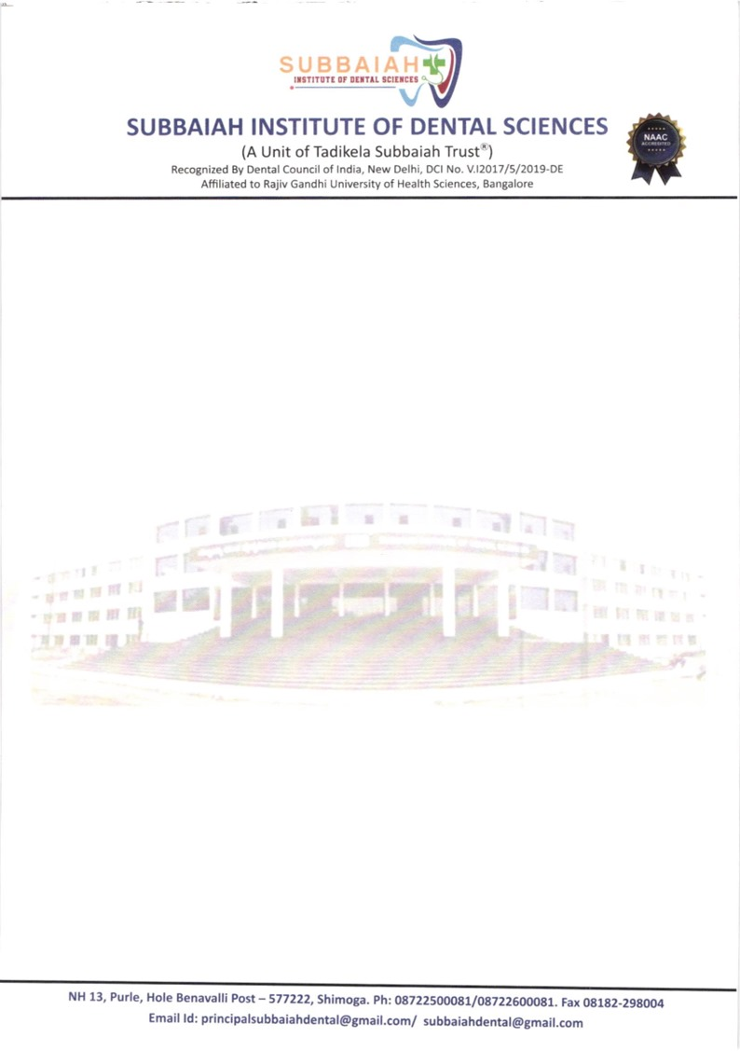



|  |  |  |  |  |  |  |
| --- | --- | --- | --- | --- | --- | --- |
| 7 | Pubmed | Case report | Diagnostic imageology of Goldenhar syndrome: report of a rare case | 1.DR.Suma m s  2. DR.Srikanth P Kunjumon | Contemporary clinical dentistry | https://journals.lww.com/cocd/pages/default.aspx |
| 8 | Scopus | Original  Research | 3dimensional Analysis of Maxillary Dentition for sex determination in humans by using software | 1.DRAkarsh Niranjan  2.Dr Shruthi D K  3. Mahesh F Balikai  4. Keerthana D R | Journal of Xidian University | https://xadzkjdx.cn/ |
| 9 | Pubmed | Original  Research | Comparative evaluation of pain perception in pediatric patients during administration of local anesthesia with and without three preanesthetic procedure-Buzzy System, topical anesthesia and precooling agent | DR. Srinivas Naidu | International journal of Contemporary pediatrics | https://www.ijpediatrics.com/index.php/ijcp |