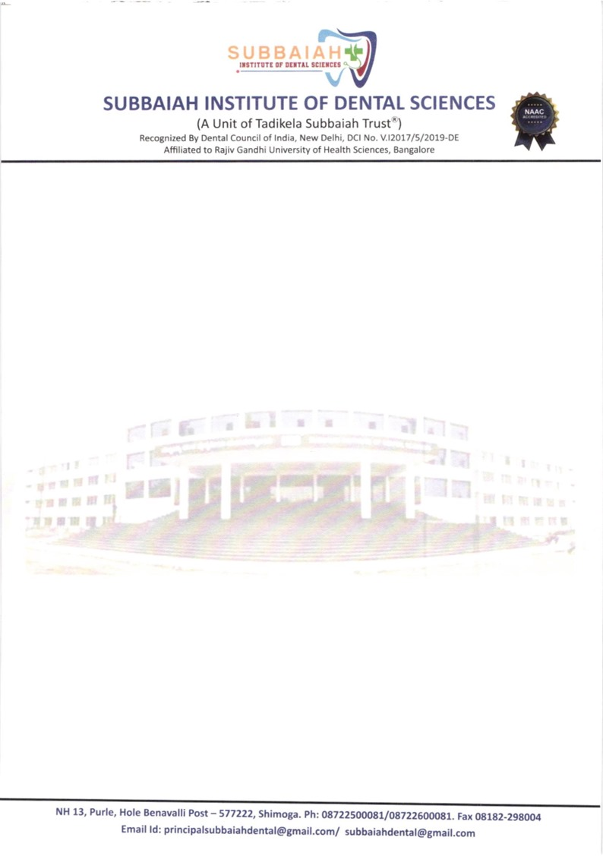

**INNOVATION ECOSYSTEM**

The University has initiated several programs to facilitate innovation and promote an entrepreneurship ecosystem on the campus for its affiliated institutions. Among those the following are the few initiatives taken in the Institutions.

**INNOVATION AND ENTREPRENEURSHIP DEVELOPMENT CELL**

Innovation and Entrepreneurship Development Cell is established in the Institute which takes measures for promoting innovation and entrepreneurship among students. Series of motivational talks on entrepreneurship were arranged for students and staff.

**INNOVATIVE LEARNING**

For the purpose of creating an ecosystem for effective learning by students, the Institution has taken measures to translate the theoretical knowledge into practical skills. Various programs are conducted to imbibe in students the research bent of mind, enhance concentration in listening to the classroom lectures, observing keenly at chair side teaching, poster presentation (both in hard and soft copy mode), table clinic presentation, case presentation competition, essay writing, and other competitions on the occasion of dedicated days like Oral Hygiene Day, Maxillofacial Day, Oral Radiology Day, prosthodontist day, Endodontist’s day, Pedodontist’s and Children’s day, Oral Pathology day, Public Health Dentistry day celebrations.

**INCUBATION CENTRE**

An incubation centre has been set up in the Institution’s premises, so as to nurture the interests of the faculty and the students in the field of innovation and entrepreneurship. The main aim of setting up the centre, is to bring together the creative and innovative minds under one roof in fields which include dentistry, engineering industry as well as academics.

**RESEARCH CENTRE**

The Institution has set up a Research and Development Centre to promote and monitor research.

Its functions are:

* Initiating research culture among faculty members and students.
* Motivating the staff to undertake minor and major research projects from various funding agencies.



